1. **What is the difference between Discrete and Continuous Data?**

Continuous and discrete are mathematical terms. Continuous means "forming an unbroken whole, without interruption"; discrete means "individually separate and distinct." In Tableau, fields can be either continuous or discrete.

1. **What is the criteria for data to land into dimensions and measures?**

Dimensions affect the level of detail in the view. Measures contain numeric, quantitative values that you can measure. Measures can be aggregated. When you drag a measure into the view, Tableau applies an aggregation to that measure (by default).

1. **What is Metadata, where is it present in the workbook?**

After connecting to the data source, Tableau captures the metadata details of the source like the columns and their data types. This is used to create the dimensions, measures, and calculated fields used in views. You can browse the metadata and change some of its properties for some specific requirements.

1. **What happens when you aggregate or disaggregate the Data?**

When you disaggregate measures, you no longer are looking at the average or sum for the values in the rows in the data source. Instead, the view shows a mark for every row in the data source. Disaggregating data is a way to look at the entire surface area of the data.

1. **You are working on a dataset, the client adds in more data to the dataset. What happens to the Visualization that you had created? Give the explanation for both Live and Extracted data.**

If you are connected to a data source that has been modified, you can immediately update Tableau Desktop with the changes by selecting a data source on the Data menu and then selecting Refresh.

Not every connection will behave in the same way. There are three primary connection types: Live Connection, Extract, and Published Data Source. The type of connection is displayed by the icon next to your data source in the Data Pane.

**Live Connection**

A live connection sends queries to the database and updates the view depending on the results. However, the specific fields queried are defined when the connection is initially created. Refreshing the data source will update any new or changed fields.

**Extract**

Refreshing an extract will query the data source the extract was created from and rebuild the extract. This process might take some time, depending upon the size of the extract.

**Published Data Source**

When connected to a Published Data Source, the data source can be either a live connection or an extract. Selecting the Data Source tab will display whether the Published Data Source is a live connection or an extract. If the data source is an Extract, all refreshes of the extract are managed by Tableau Server and can only be refreshed by the server.

**Changes to underlying data**

If a field that is used in a Tableau worksheet is removed from the underlying data of the data source and then the data source is refreshed, a warning message displays indicating that the field will be removed from the view and the worksheet will not display correctly because of the missing field.

If the underlying data changes—for example, if new fields or rows are added, data values or field names are changed, or data is deleted, Tableau will reflect those changes the next time you connect to the data source. However, because Tableau Desktop queries the data and does not import the data, you can immediately update Tableau to reflect the data modifications without disconnecting, provided the changes have been saved in the underlying data first.

1. **What are the file extensions in Tableau and how each one is different?**

The different file extensions in Tableau are as follows:

**1. Tableau Workbook (.twb)**

The Tableau Workbook file type is the one that you will use the most when working in Tableau. This file type has the extension .twb and is set as default for the users. As we know, a workbook in Tableau is a file that contains sheets, dashboards, etc. So, this particular Tableau file type contains information about worksheets and dashboards present within a workbook. All the information regarding the fields, aggregation types, styles, formatting, filters, etc is present in these files.

One important thing to note about this Tableau file type is that we can only create them if we are using live data connections and share them only with the users having access to the same live data connection. The .twb files also contain metadata related to the existing data connection. However, a .twb file does not contain actual data concerning the workbook.

To create .twb file, go to the data source control panel of the active data connection and then go to File option (present on the toolbar) and select Save As. Then, you can select the file type as Tableau Workbook from the Save As Type drop-down list.

**2. Tableau Packaged Workbook (.twbx)**

The Tableau Packaged Workbook file type has both information about the constituents of a workbook and the data extracted from the data source. The data extract taken from the source is present in the form of a .tde file. Tableau Packaged Workbook files have an extension .twbx. You can use a .twbx file type in place of a .twb (Tableau Workbook) file when you wish to share a workbook with a user who does not have access to the live data connection. Thus, in this case, you need to have a file which contains data extracted from the source along with the other information about the workbook.

The Tableau Packaged Workbook files can also contain information about attached images or customized geocoding. To create a .twbx file, go to File then select Save As and then select the .twbx option from the drop-down list given there.

**3. Tableau Data Source (.tds)**

The Tableau Data Source files are files that contain all the necessary information regarding a data connection made in Tableau. When we set up a fresh connection to a data source we make a lot of modifications in it as per our requirements such as setting data types, aggregations, custom fields, etc. The Tableau Data Source files contain all the required information on setting up a data connection along with the metadata of other specific modifications made by the users.

The .tds file helps in saving information on data connections with custom fields and table joins. However, this Tableau file type only saves the information needed to establish a connection with a data source but not the actual data. Thus, such files can be used to share information between users having access to the same data source.

To create a .tds file, go to the Data tab on the toolbar. Then choose a data source that you wish to connect to and select Add To Saved Data Source option. After this, save that file as Tableau Data Source file.

**4. Tableau Packaged Data Source (.tdsx)**

A Tableau Packaged Data Source file is a file that contains information of a data source connection along with the data extracted from that source. The extracted data is saved as a .tde file and the information on data source as .tds file (like we saw above). The extracted data can be from any local file such as a text file, extract files (.hyper or .tde), Excel files, Access files, etc.

However, the extension of a Tableau Packaged Data Source file has the extension as .tdsx. The Tableau Packaged Data Source files are used when we want to share data and other relevant information about a data source with a user who does not have access to the data source and its data.

To create a .tdsx file, go to the Data tab on the toolbar. Then choose a data source that you wish to connect to and select Add To Saved Data Source option. After this, save that file as Tableau Packaged Data Source file.

**5. Tableau Data Extract (.tde)**

The Tableau Data Extract files have the extension .tde. These Tableau file types only contain a local copy of the entire or a subset of data from its source. It is important to note here that the .tde files do not contain a file path or information about the data source, workbooks, dashboards, etc. Tableau Data Extract files are important and useful as they are highly compressed and optimized to improve Tableau’s performance (especially when you are using a slow data connection). You can use .tde files for offline work as well. One noted drawback of such Tableau file types is that the data in it cannot be refreshed automatically as and when it refreshes at the source. However, Tableau has a few step process to refresh the data present as an extract in your .tde files.

To create a Tableau Data Extract (.tde) file, go to the Data tab present on the top left of the Tableau toolbar. Select a data source and click on the Extract Data option. After this, you can either select fields from the data source that you wish to extract or just click on Extract to create a data extract file (.tde) of the entire data set present at the data source.

**6. Tableau Bookmark (.tbm)**

Files with the extension .tbm are Tableau Bookmark files. These Tableau file types are most commonly used to save worksheets and share them with others so that they can use it in their workbooks without having to create a new worksheet from scratch.

To create a .tbm file, go to the Windows option present on the toolbar. From there, select Bookmark and then click on Create Bookmark. This will create a .tbm file of the active worksheet.

However, with the newer version of Tableau that was released, the use of Bookmark files has gone down. In Tableau versions 8.1. and later, we can directly copy and paste worksheets from one workbook to the other without having to create a .tbm file for it.

**7. Tableau Map Source (.tms)**

A Tableau Map Source file contains information about maps and its elements for use in Tableau. The extension of such files is .tms. As per the default settings, Tableau will fetch map details like background and other layers from a certain map server or provider. In Tableau, you have the option to add map details from a WMS server of your choice or a custom map from Mapbox. Once you create a map file (.tms) of your preference, Tableau will fetch map details from that file instead of the default one and load map images and information accordingly. You can also share these .tms users in your group for others to use.

To create a Tableau Map Source (.tms) file, click on Map from the toolbar. Then go to Background Maps and select WMS Server from Map Services> Add. After adding the map server of your choice, you can export it to your local desktop by selecting an Export option from the WMS Server connections window. To use this map in future, add the .tms file into the Tableau Repository in the Map sources directory.

**8. Tableau Preference (.tps)**

A Tableau Preference file contains all the information related to a customized color palette. You can create a custom color palette or a theme and save it as a .tps file so that you can use it all over the workbook uniformly at once. The Tableau Preference files have the extension as .tps and exist in XML format. These Tableau Preference files are present in My Tableau Repository.

**Questions related to PARAMETERS**

**1. Parameters can be used in?**

Parameters are like containers of values in Tableau. We can use parameters dynamically to enter values that are not fixed or present in our data set originally. For instance, we can enter a more than/less than condition into a parameter, set a range for values that we wish to focus on in our analysis, select top values, etc.

We can program the Tableau parameters in such a way that at the user end, the control of the dashboard shifts entirely to the user from the author. A user can easily interact with the dashboard elements through parameter values. A parameter can be a string value, a numeric value, a range of numbers, a currency and a lot more. Thus, in this way parameters offer a lot of flexibility and freedom to the Tableau users to think of new scenarios and play with data in a manner that gives them maximum output in the form of useful insights from data.

**2. What are the different ways to create a Parameter?**

Steps to Create a Parameter in Tableau

**Step 1:**

To create a parameter, click on the drop-down arrow present on the top right corner of the Data pane. Select Create Parameter option from the drop-down menu.

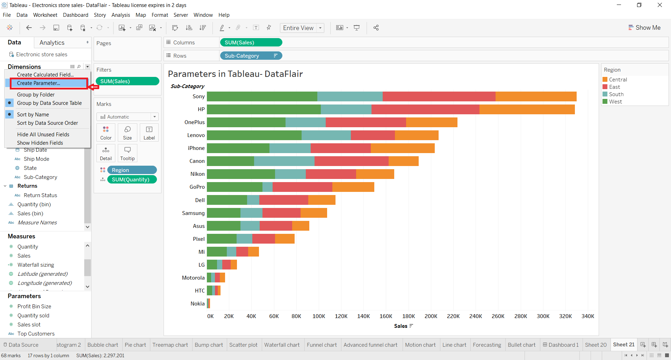

**Step 2:**

A Create Parameter window will open. From this window, you can give a name to the parameter, select its data type, set current value, allowable values, etc.

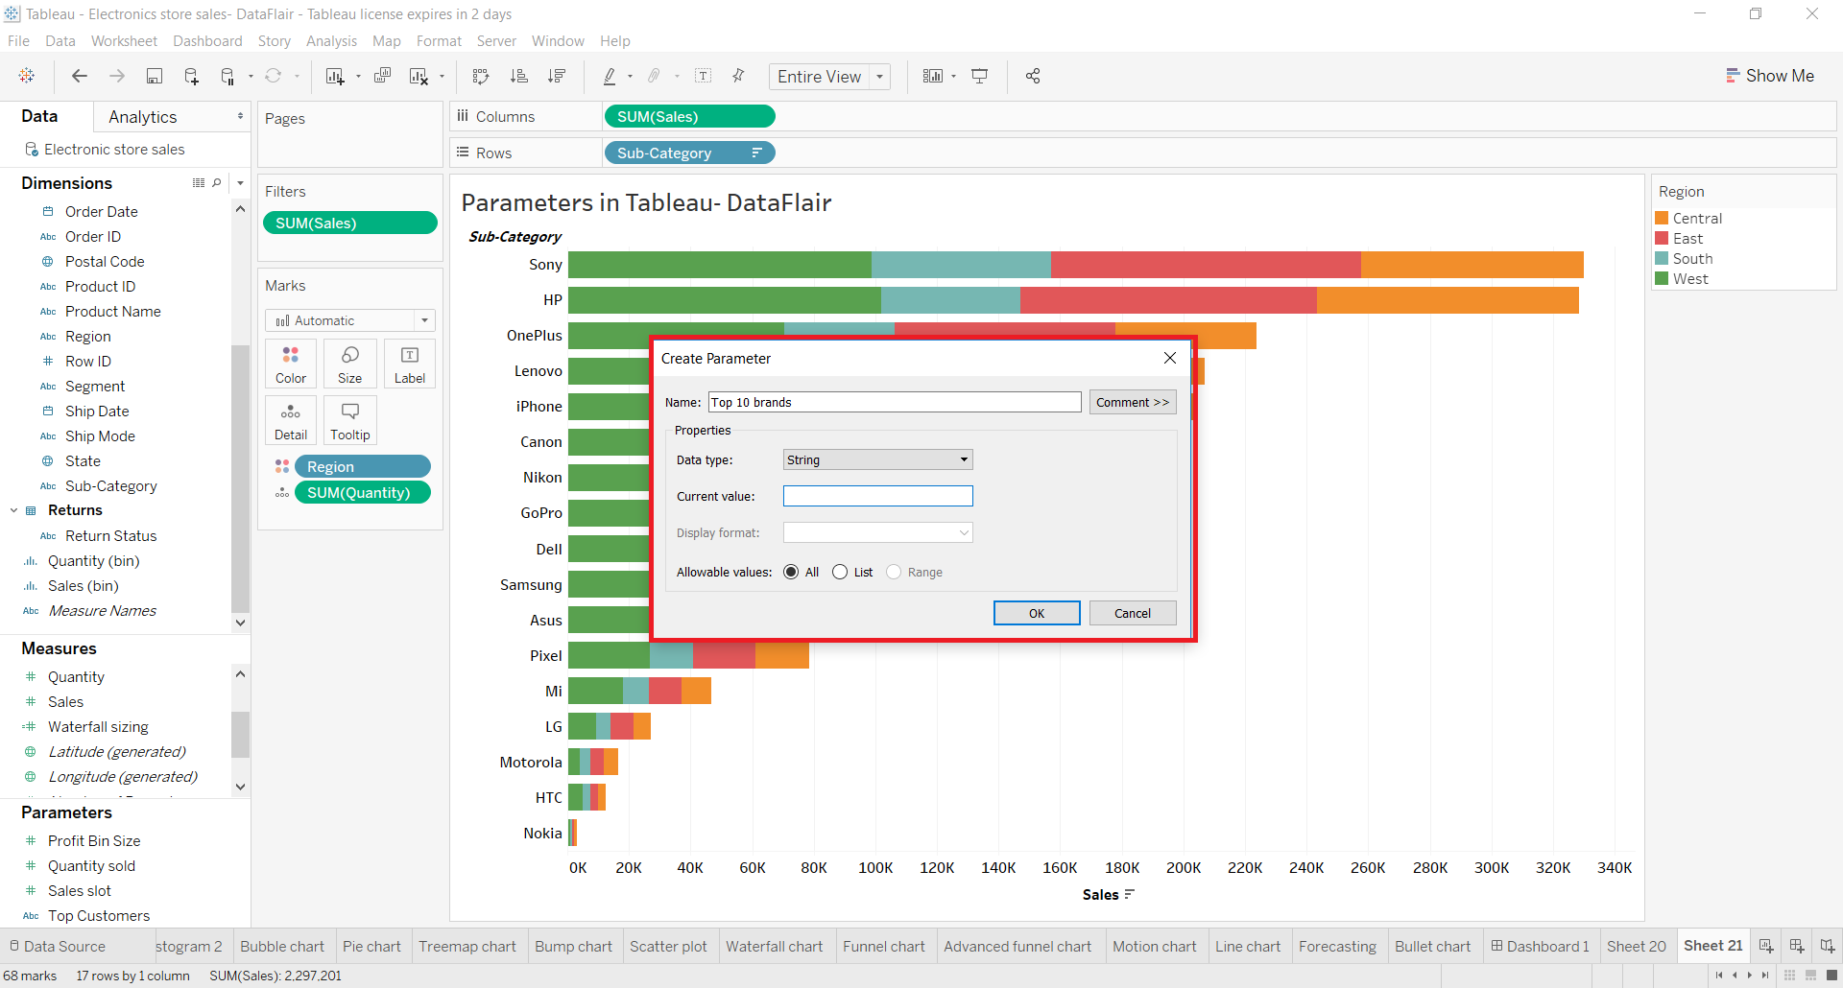

We can add a data type we prefer from the list of available data types as shown in the screenshot below.

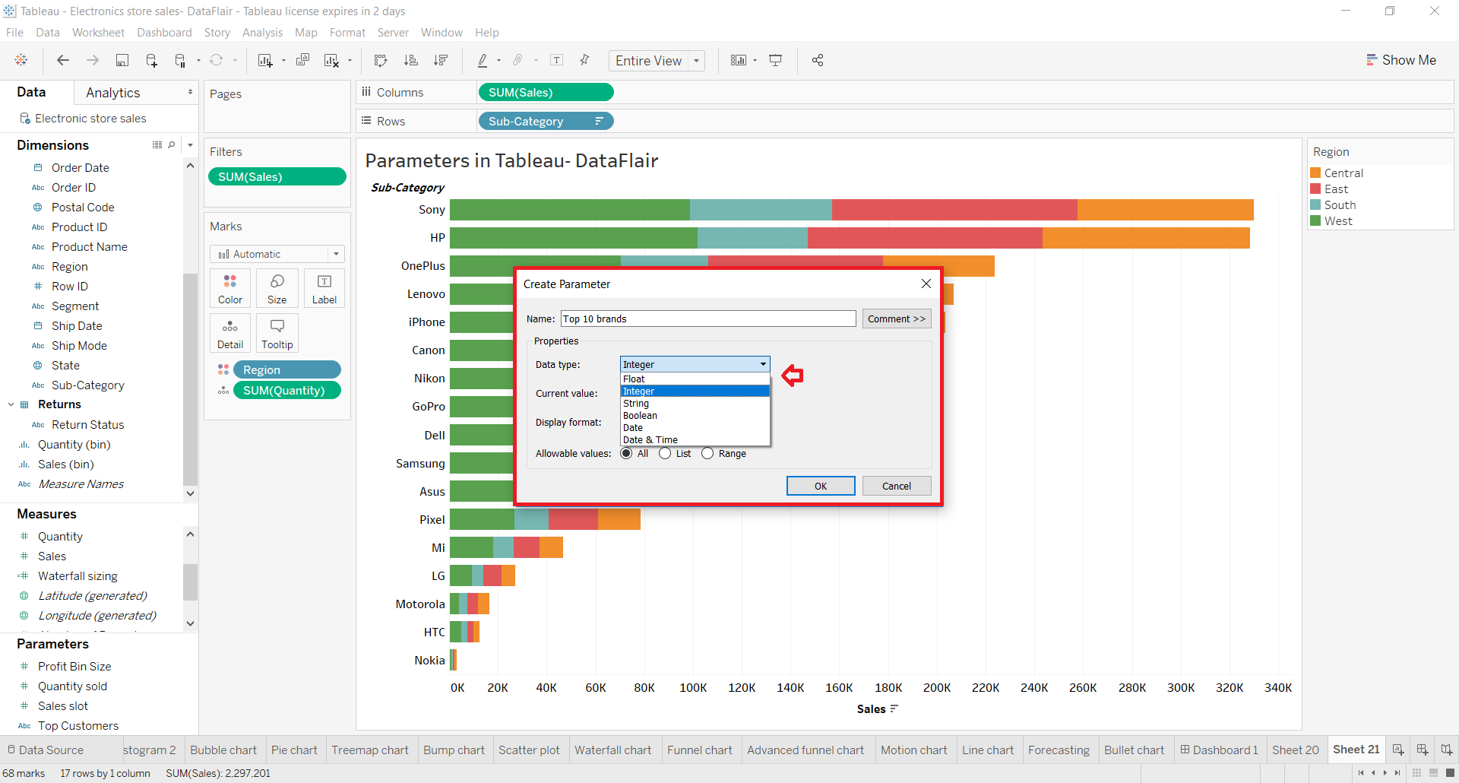

**Step 3:**

You can also select a display format for the parameter that you are creating. The formats available are Number, Currency, Scientific, Percentage, Automatic, Custom, etc.

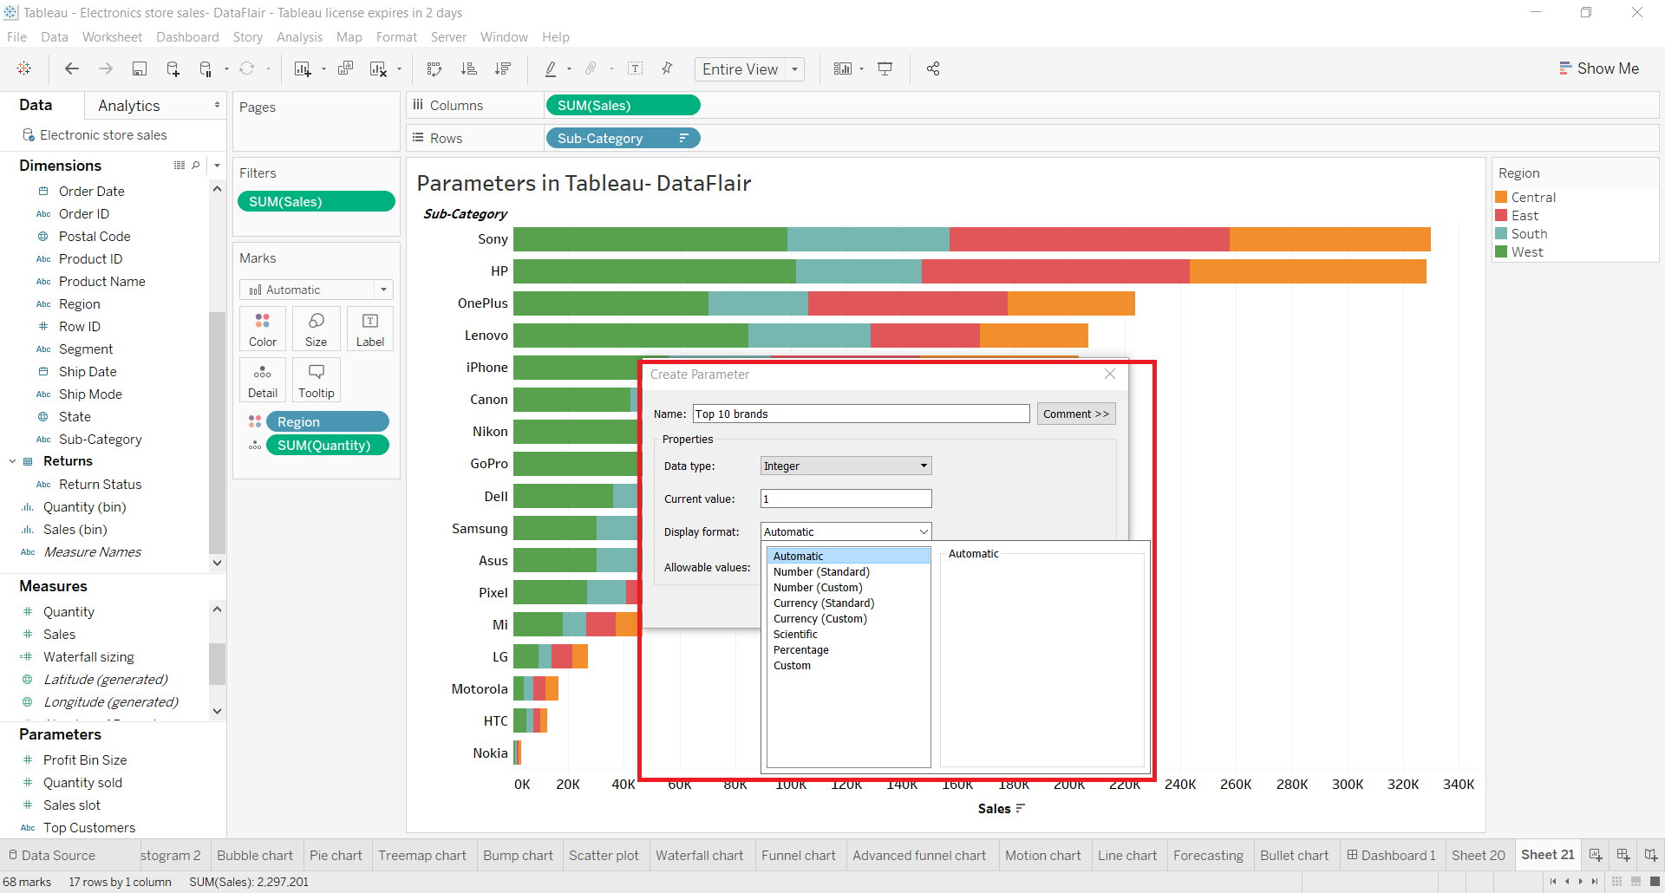

**Step 4:**

From the next option of Allowable values, you will find three options; All, List and Range. This means that we can either select all the values within a field and create a parameter. Or we can have a list of values of our choice from the field or we can set a range within which we would like to have values in the parameter.

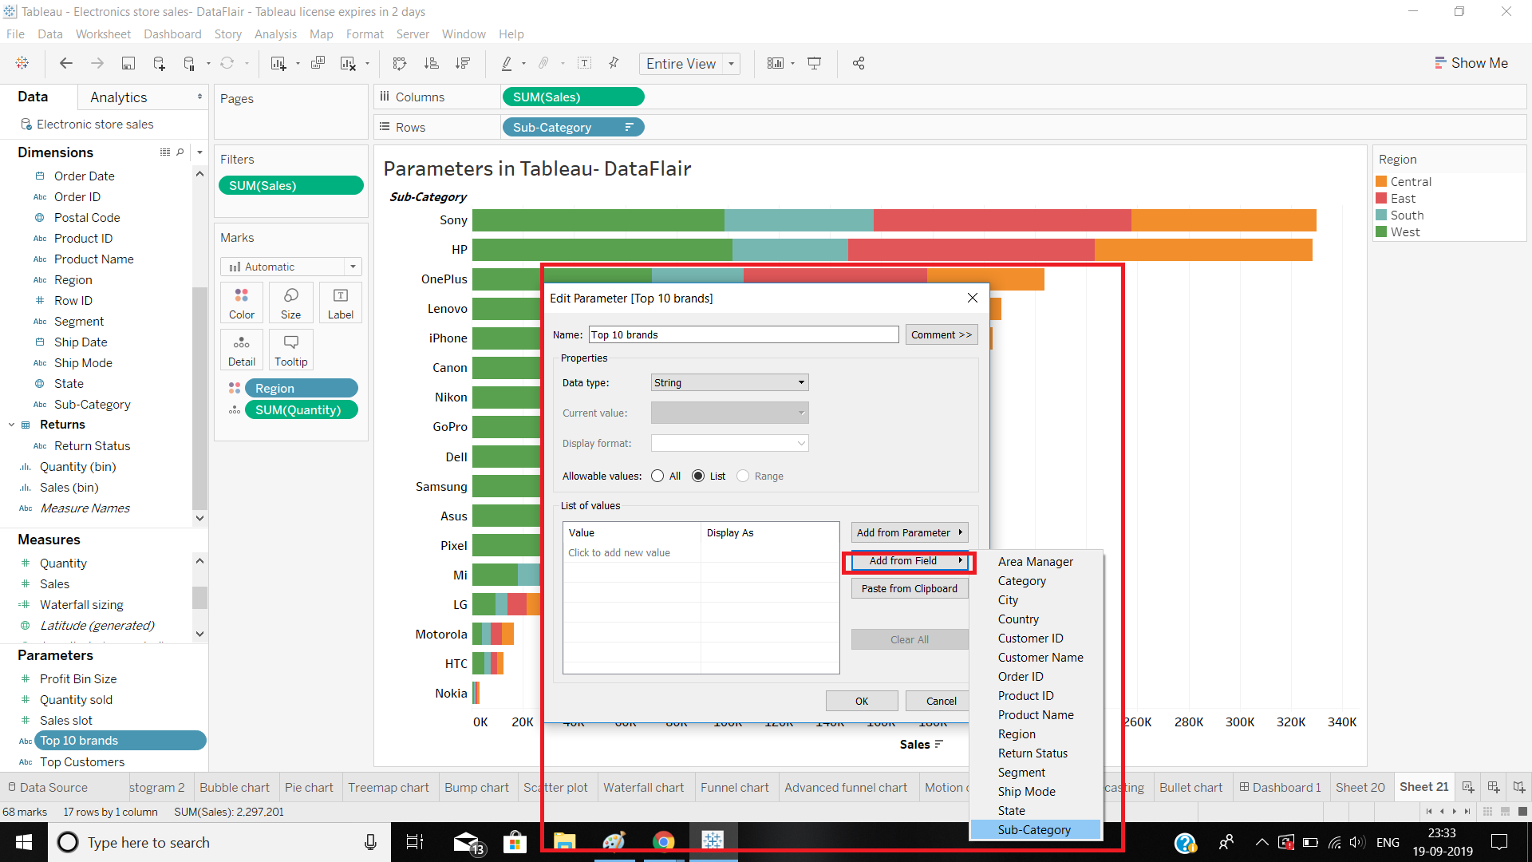

For instance, let us add field values for our parameter from the Add from field option. We select the field Sub-category from our list of fields.

A list of all the values within a field appears in the List of values section. You can remove selected field values from the cross (⨯) icon given next to them. Once you are done with selecting or removing values from the field, click on OK.

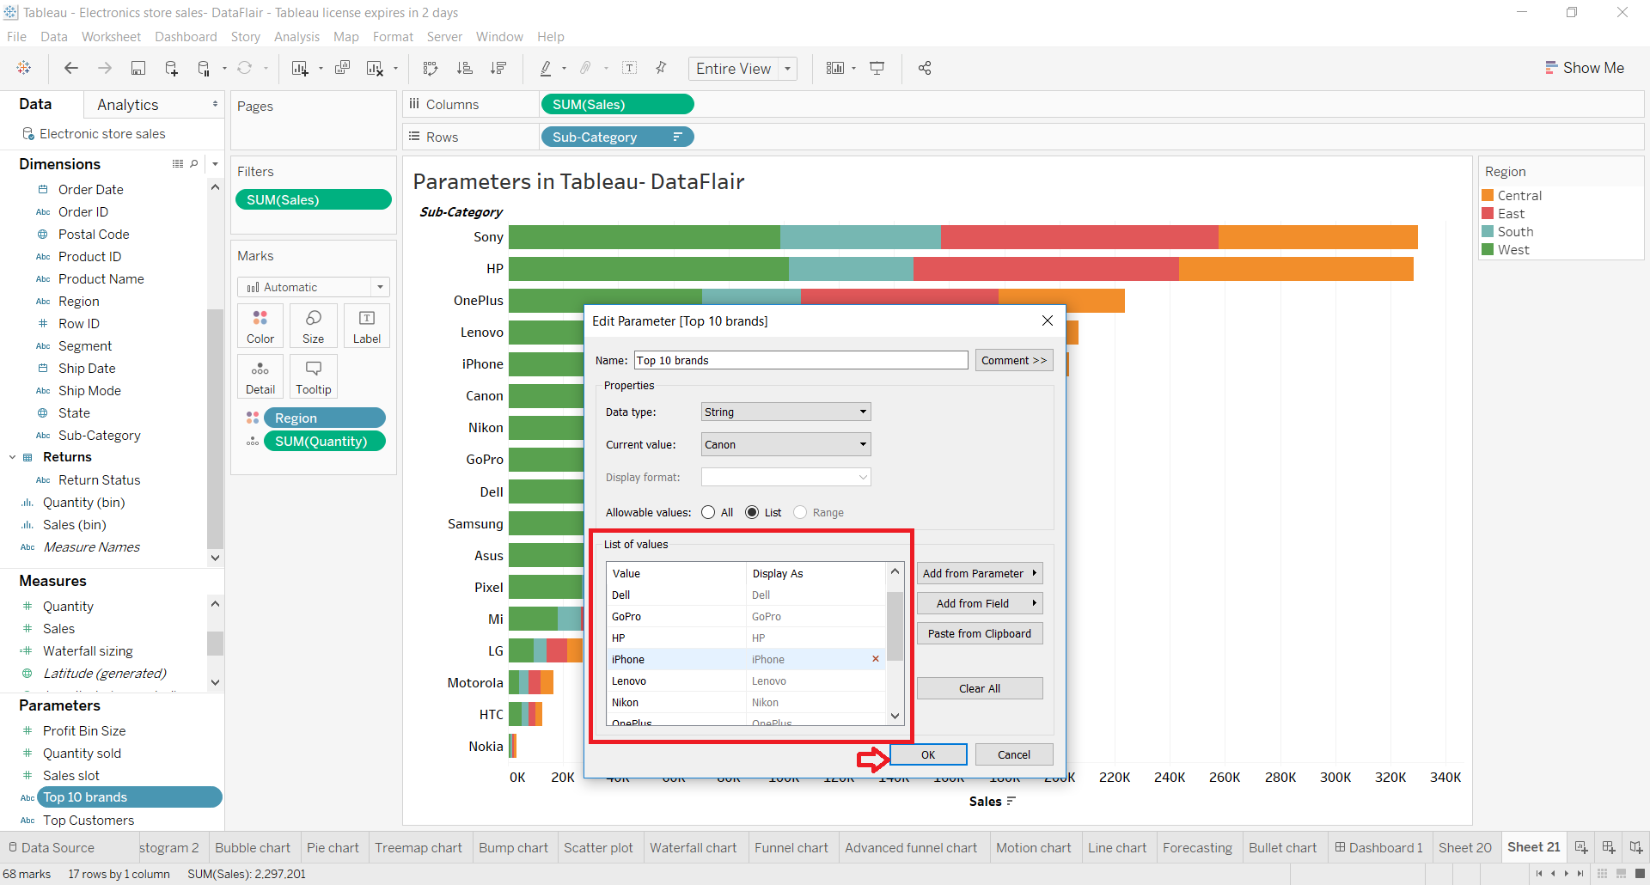

**Step 5:**

In this way, the newly created parameter “Top 10 brands” starts showing in the Parameters section given at the bottom left.

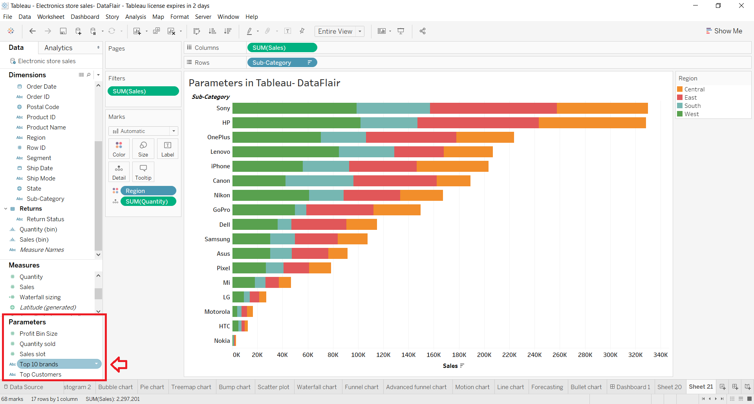

**Using a Parameter**

Once a Tableau parameter gets created we can add it to a sheet by right-clicking on the parameter’s name and selecting Add to Sheet option. From this drop-down menu, you can use a lot of other options on the parameter such as edit, copy, duplicate, rename, hide, delete, create, describe, etc.

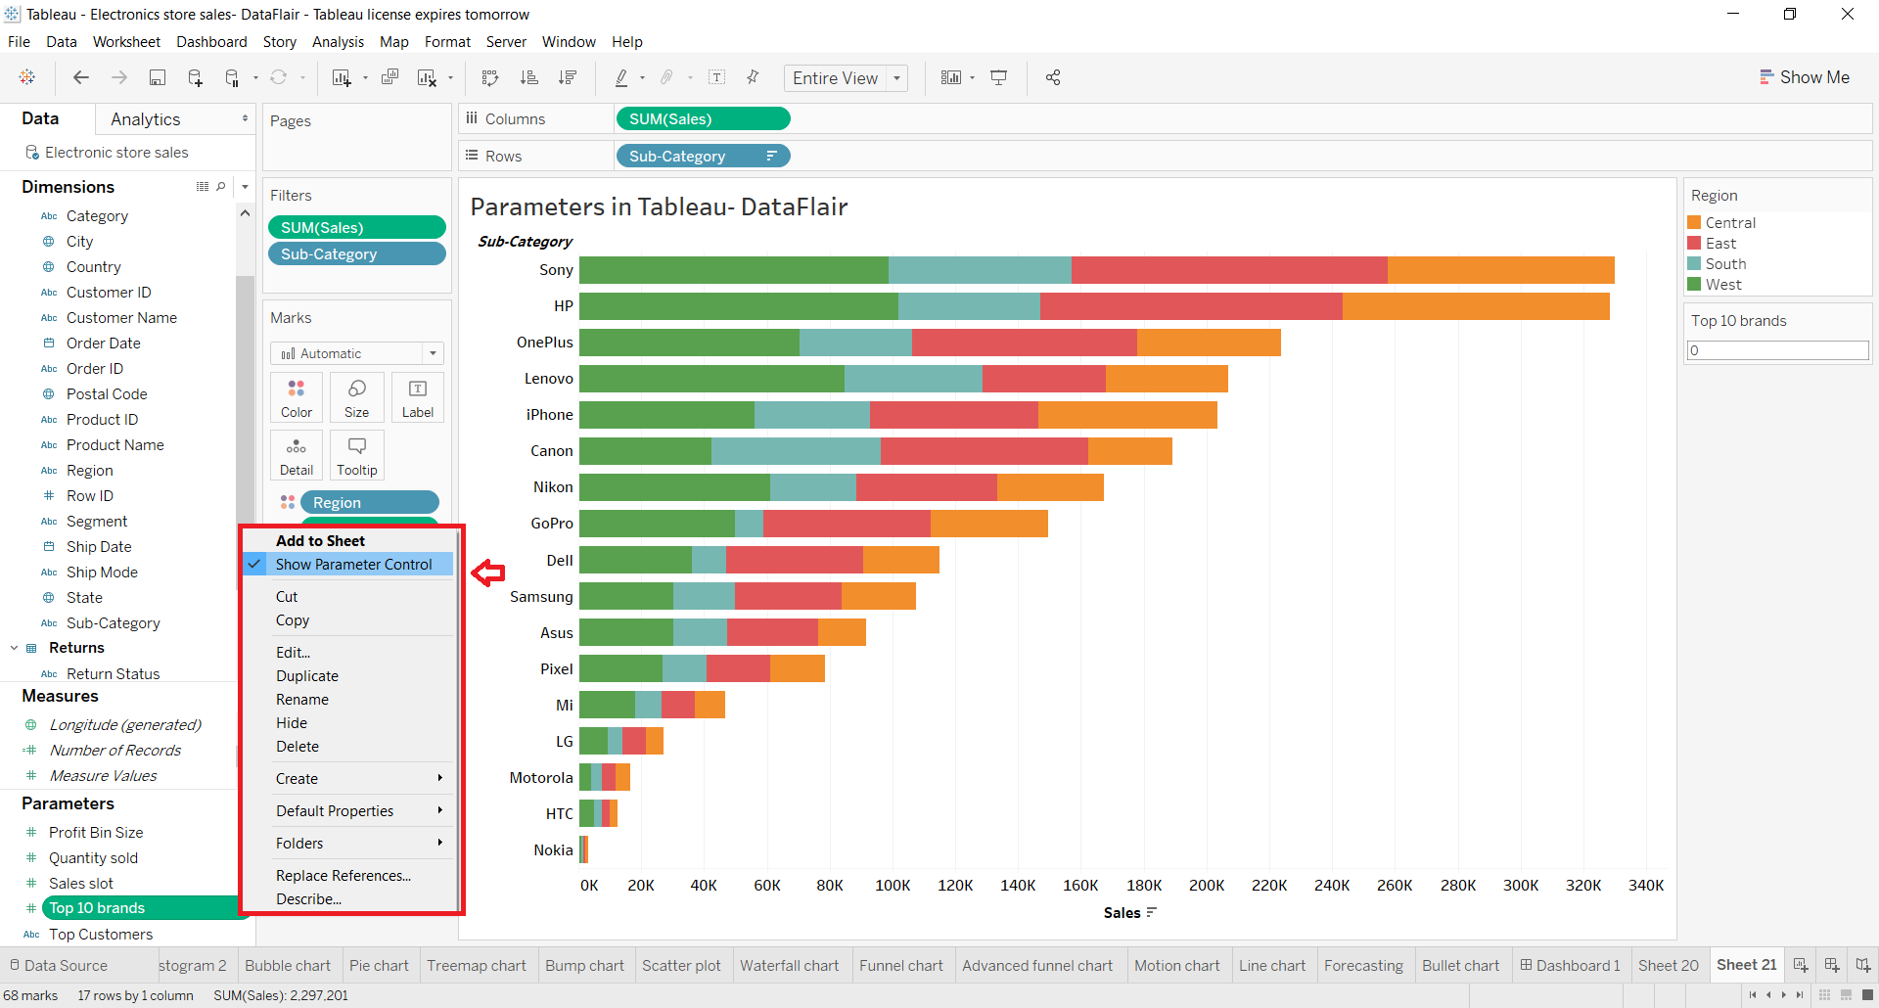

If you select the Show Parameter Control option, a new parameter control box appears on the right from where you can enter values manually to view selected parameter values.

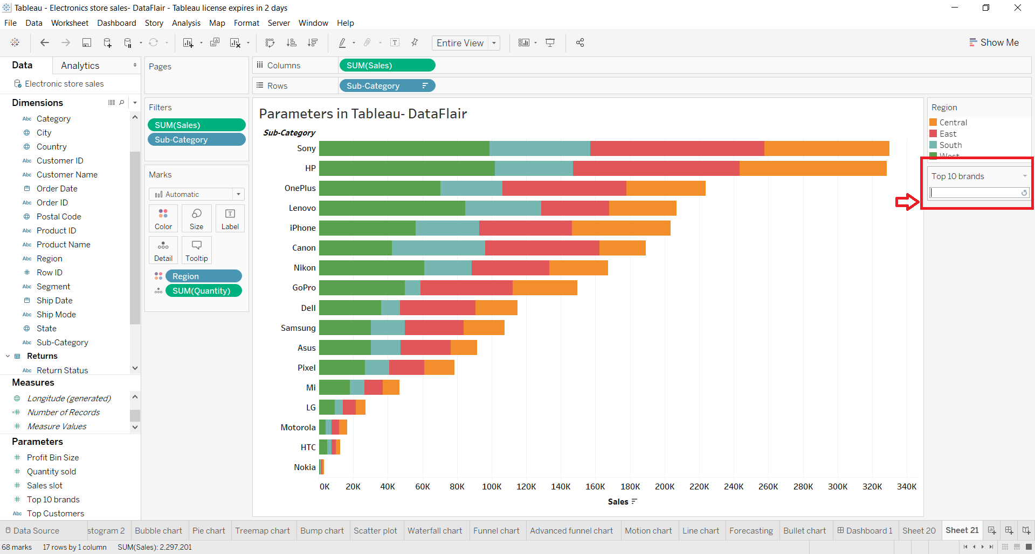

To hide this card or box, right-click on it and select the Hide Card option. Also, from this drop-down menu, you can edit the parameter, edit title, format the parameter and select the type of parameter card such as Type In, Single Value List, Slider, and Compact List.

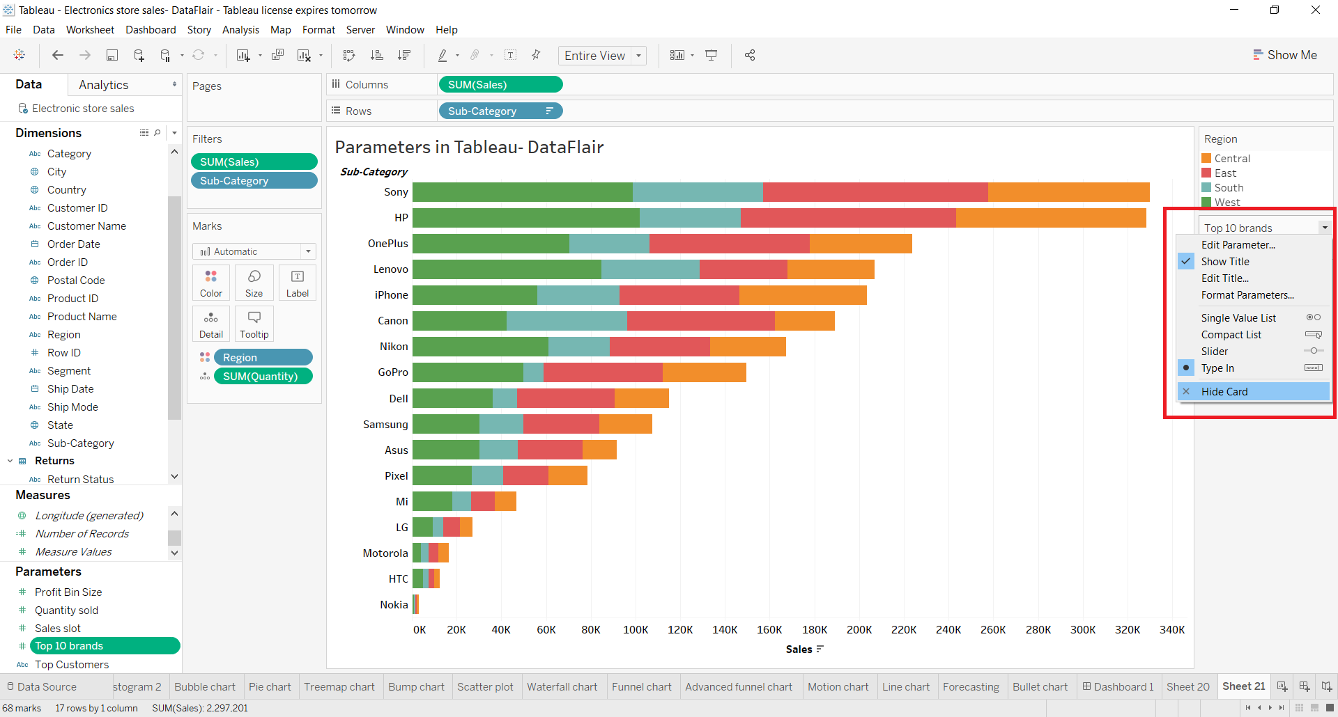

**Edit a Parameter**

If you wish to edit an already existing parameter, right-click on the name of the parameter and then select Edit.. option from the drop-down menu.

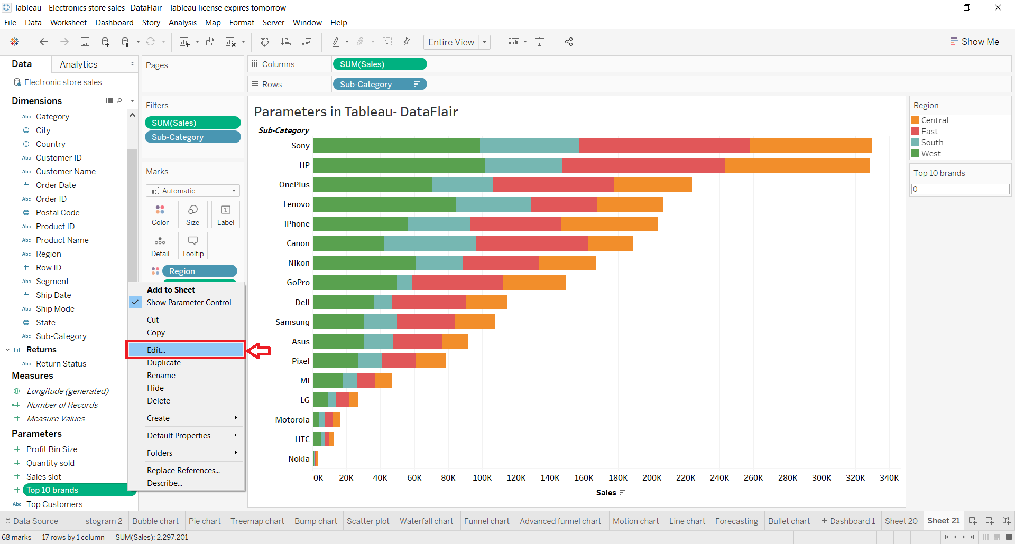

**Parameters in Filter**

We can also use the parameters while applying filters. Also, we can instantly create new parameters from the Filter window. To do this, open the drop-down menu and select Create a New Parameter.. option.

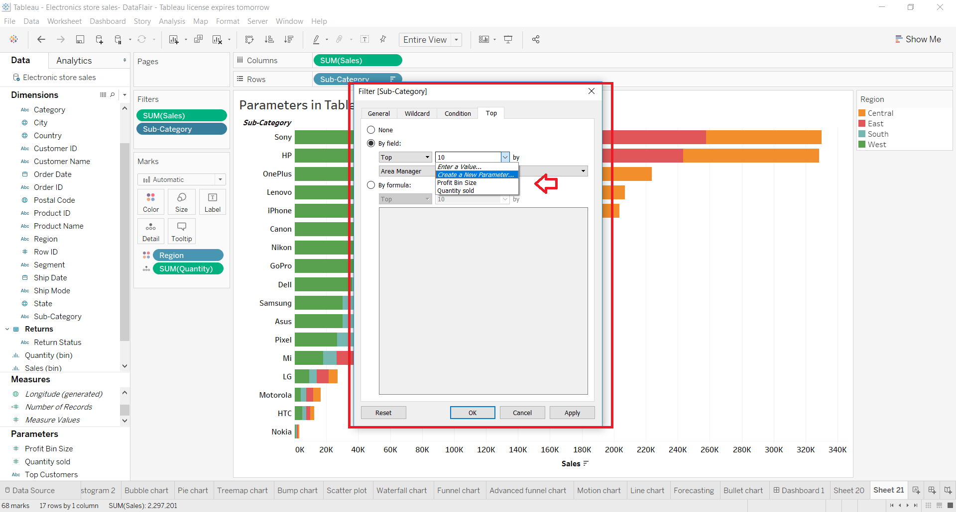

In the next window, you are given the options to create a new parameter from scratch.

Here, we create a range of 10 values. Click on OK once you are done with creating the parameter.

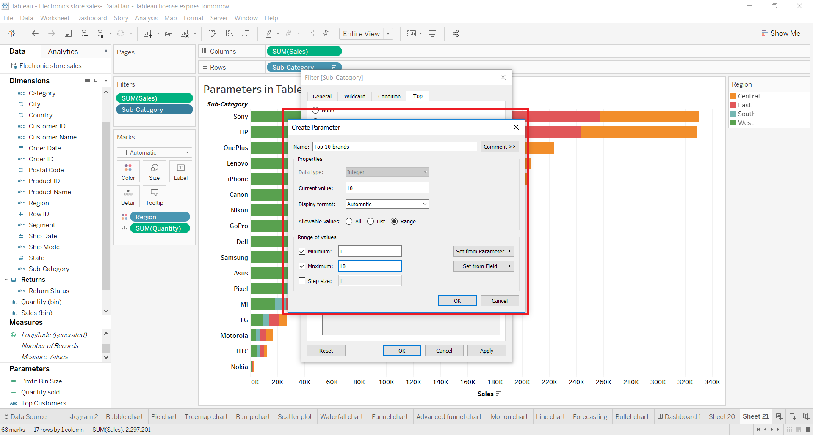

As you can see in the screenshot below, a Tableau parameter filter of the top 10 brands or sub-category values is applied to our bar graph. This graph only shows region-wise sales for the top 10 electronic brands.

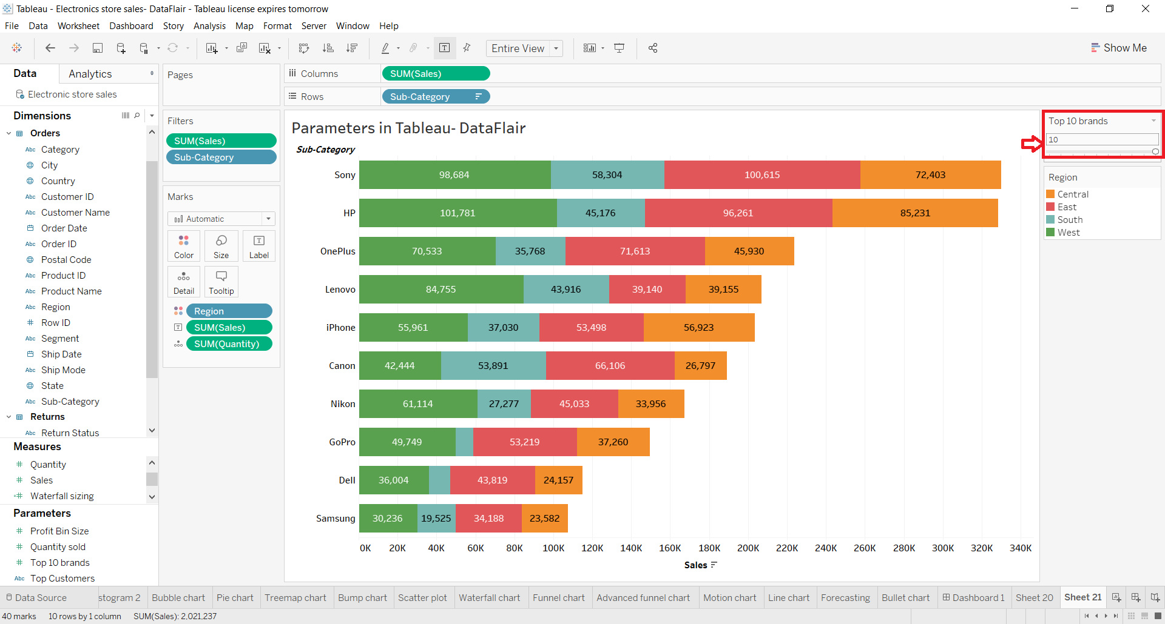

We can also manually enter values in this type-in filter. For instance, we only want to see the sales for the top 6 brands instead of 10. This can be achieved by entering number 6 in the filter. By doing this, Tableau will show the sales value for the top six brands.

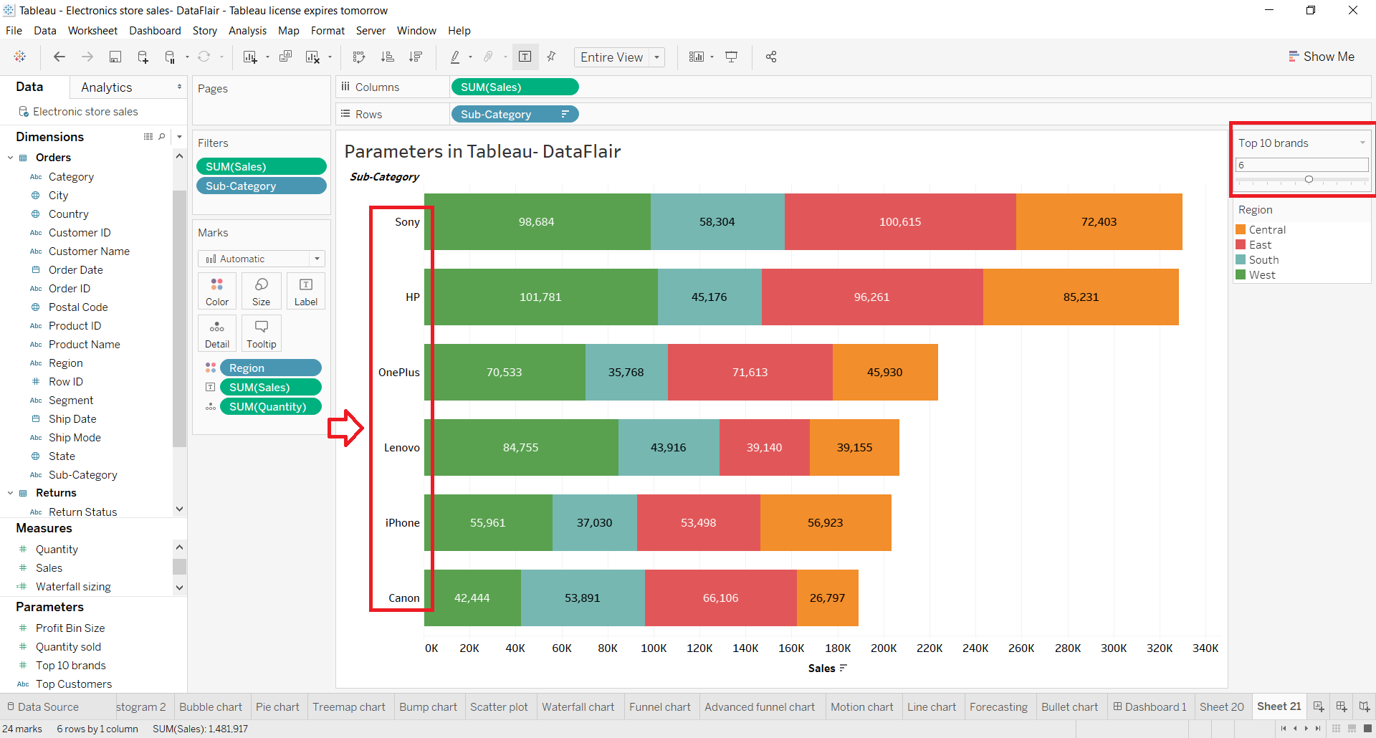

**Questions related to Calculated fields**

**1. How do you create a profit ratio using the Calculated fields?**

In a worksheet in Tableau, select Analysis > Create Calculated Field. In the Calculation Editor that opens, give the calculated field a name. In this example, the calculated field is called Profit Ratio.

**Questions related to Dashboards**

**1. What are the different device type preview that Dashboards can use?**

Dashboards can include layouts for different types of devices that span a wide range of screen sizes. When you publish these layouts to Tableau Server or Tableau Online, people viewing your dashboard experience a design optimized for their phone, tablet, or desktop. As the author, you only have to create a single dashboard and deliver a single URL.

**How the Default dashboard relates to device layouts**

Device layouts appear on the Dashboard tab, under Default. Initially, each device layout contains every item in the Default dashboard and derives its size and layout from Default as well.

Think of the Default dashboard as the parent, and the device layouts (desktop, tablet, and phone) as its children. Any view, filter, action, legend or parameter that you want to add to a device layout must first exist in the Default dashboard.

**Phone layouts and the Default dashboard**

To save time with a unique Phone layout option that automatically reflects changes to the Default dashboard, either click the open lock icon , or choose Auto-Generate Layout from the pop-up menu.

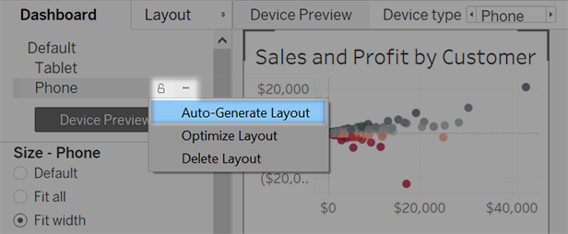

If you instead click the closed lock icon or choose Edit Layout from the menu, the Phone layout becomes fully independent, so you'll need to manually add and arrange items to reflect changes to the Default dashboard.

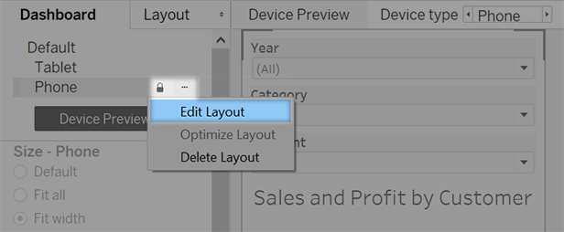

**Desktop and Tablet layouts and the Default dashboard**

Unlike Phone layouts, you need to manually add Desktop and Tablet layouts to a dashboard. Desktop and Tablet layouts are always fully independent from the Default dashboard, so each device layout can contain a unique arrangement of objects.

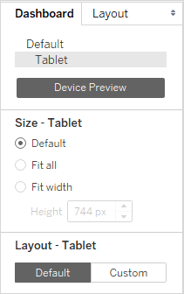

**Automatically add phone layouts**

Two options let you automatically add phone layouts:

* To create phone layouts whenever you open old dashboards that lack them, choose Dashboard > Add Phone Layouts to Existing Dashboards
* To create phone layouts whenever you create a new dashboard, choose Dashboard > Add Phone Layouts to New Dashboards. (This option is on by default.)

**Preview and manually add device layouts**

1.Open a dashboard.

2.On the Dashboard tab on the left, click Device Preview.

3.Take a moment to click through the Device types and Models and explore the different screen sizes. Then set these options:

* To see how the dashboard will look in landscape vs. portrait mode, click . Usually, landscape is optimal for tablets and portrait is best for phones.
* Select Tableau Mobile app to see how the dashboard will look with the app instead of the browser. This option is available for iOS or Android devices and shrinks the dashboard slightly, leaving space for the app controls.

4. Choose a Device type, such as Tablet.

5. In the upper-right corner, click the Add Layout button for the device type you selected (for example, Add Tablet Layout).

6. Add an additional layout by selecting a new Device type and clicking Add Layout.

Creating a layout for each device type gives you the most control over your users' experience as they view your dashboard from different devices. After you publish a dashboard with all three layouts, users won't see the default dashboard layout; instead, they'll always see the appropriate device-specific layout.

**Customize a device layout**

After you've added a device layout to your dashboard, you can start rearranging objects to create the look you want.

1. For Desktop and Tablet layouts, click Custom:

For Phone layouts, either click the lock icon , or choose Edit Layout from the pop-up menu:

2. Anything you can add to your layout is listed on the left, under Layout. If an item has a blue check mark, it means that it's part of the device layout that you're currently working on.

3. If you remove an item, it's only removed from the current device layout. It still exists on the default dashboard and can be added to the device layout again.

4. Click through the Device model options to see how the layout will appear on different models.

Ultimately, it's the size of the web browser that loads the dashboard that determines which layout appears on the device. For details, see Confirm which layout a device will display.

5. At left, explore the options under Size.

**Default**: The height and width of the device layout mimics whatever the default dashboard is using. For example, if you're creating a tablet layout and the default dashboard is set to a fixed size of Desktop Browser (1000 x 800), setting Size to Default for the tablet layout will make it use 1000 x 800 as well.

**Fit all**: All items are automatically resized to fit the device frame size. The device frame size is determined by the Device type, Model, and orientation (portrait or landscape) settings.

**Fit width** (recommended for phones): Items are automatically resized to fit the width of the device frame, but the height is fixed. This is a great option for phone layouts and vertical scrolling.

**Optimize for phones**

The small screens of mobile phones benefit from further optimization. Try these techniques.

**Optimize manual phone layouts**

If you've chosen to edit a phone layout yourself, you can quickly optimize the placement of filters, remove white space, and more. On the Dashboard tab, click the pop-up menu to the right of Phone, and select Optimize Layout.

Be aware that this command only rearranges items currently in the phone layout. If you want to continuously update the phone layout to reflect all changes to the default dashboard, select Auto-Generate Layout.

**Add links that trigger instant messages and phone calls**

To let phone users quickly contact key people about dashboard content, add URL actions to objects that automatically trigger SMS messages and telephone calls. Use the link format sms:phone-number or tel:phone-number. Be sure to include country and area codes if necessary.

**Create phone-specific versions of views**

Create duplicates of certain views in the default dashboard—one optimized for desktop viewing and a second optimized for phones.

1. Go to the worksheet for a view, click its tab, and select Duplicate Sheet.

2. Customize the view for mobile viewing.

For maps for example, you may want to zoom in to a specific region by default, or you may want to disable panning, zooming, and other functionality. See Customize How People Interact with your Map.

3. Now add the new view to the default dashboard so that it can be available to the device layouts you're creating.

**Shorten titles**

Short titles work best for mobile viewing. To edit a title, double-click it.

**Optimize white space**

White space is another visual element to consider. While screen real estate on a phone is scarce and you want to make the most of it, you may also want to provide additional safe places for your users to tap or initiate scrolling, so they don't select filters and other items unintentionally.

To add white space, use padding or Blank objects. For more information, see Size and Lay Out Your Dashboard.

**Publish the dashboard**

1. Click Server > Publish Workbook. If you're not already signed in, you're prompted for your credentials.

2. In the Publish Workbook to Tableau Server dialog box, make sure the Show sheets as tabs check box is cleared.

When this check box is selected for device-specific dashboards, the tabs' sizing requirements interfere with the server's ability to correctly detect the size of the web browser and load the correct layout.

3. Click **Publish**.

**Test the dashboard**

After you publish the dashboard to Tableau Server or Tableau Online, test the dashboard by viewing it from different browser sizes.

1. Open the dashboard on Tableau Server or Tableau Online.
2. In the upper-right corner of the page, click Share and copy the contents of the Link text box.
3. Paste the string into a web browser URL. The string should include the following: embed=y
4. With the embed code string as your browser URL, test the different layouts by changing the size of your web browser window and refreshing it.

**Confirm which layout a device will display**

The dashboard layout a device displays is based on the smallest dimension (height or width) of the iframe in which the Tableau view appears. Sometimes Desktop, Tablet, or Phone layouts may appear on other types of devices. For example, a Tablet layout may appear on a desktop computer if the display or browser window is small.

If the smallest iframe dimension is ... This device layout appears ...

500 pixels or less Phone

Between 501 and 800 pixels Tablet

Greater than 800 pixels Desktop

If Tableau Online and Tableau Server users find a Phone or Tablet layout too limiting, they can click See Desktop Layout in the toolbar. This toggle button lets users switch back to the mobile device layout at any time.

**Questions related to Filters**

**1. What are the different types of filters and give their working order?**

Tableau is one of the most popular tools in data visualization and analysis that facilitates brands across all domains to leverage the reckoning potential of acquiring Business Intelligence. For its seamless capability to yield readable insights and simplified dashboards, tableau has been instrumental for even non-technical subscribers to have access to personalized datasheets.

There are different types of filters in a tableau that can be used to organize data based on predefined conditions and use them for data visualization. Such ability to filter large data sets in the Business Intelligence tool helps prepare for analysis, including removing irrelevant data records, reducing data sizes for faster processing, and more. The filters are required to highlight any underlying insights that can be derived from the data upon visualizing in a readable, actionable format.

**Different Types of Filters in Tableau**

Filters are a smart way to collate and segregate data based on its dimensions and sets to reduce the overall data frequency for faster processing. There are six different types of filters in tableau desktop based on their various objectives and are mentioned below as per their execution steps.

**1. Extract Filters**

As understood by its name, the extract filters are used to extract data from the various sources, by saving a screengrab of the way it gets added on your file. Such methods can help in lowering the tableau queries to the data source. As soon as you are done extracting data into your dashboard, you can create the extract and execute Hide All Unused Files to clear the columns unused in the datasheet of your panel.

**2. Data Source Filter**

Used mainly to restrict sensitive data from the data viewers, the data source filters are similar to the extract filters in minimizing the data feeds for faster processing.

The data source filter in tableau helps in the direct application of the filter environment to the source data and quickly uploads data that qualifies the scenario into the tableau workbook. To execute such processes, you need to go to the Data Source tab and select the Add option in the upper right corner.

Clicking on the Add option in the menu would open into a dialog box, where you can select the field and choose through the values you want to record. Once you press confirmation, you shall be presented with a summary of the presets selected from the data source filters.

**3. Context Filter**

A context filter is a discrete filter on its own, creating datasets based on the original datasheet and the presets chosen for compiling the data. Since all the types of filters in tableau get applied to all rows in the datasheet, irrespective of any other filters, the context filter would ensure that it is first to get processed.

Despite being constrained to view all data rows, it can be implemented to choose sheets as and when required to optimize its performance by minimizing the data efficiently.

The context filter helps in applying a relevant, actionable context to the entire data analysis in tableau. If there are multiple filter preset categories used in the worksheet, dividing it into many parts can overall turn into a context filter in itself that guides all the other filters present in the datasheet.

**4. Dimension filter**

Now that you’ve chosen the data, you can access the values highlighted or remove them from the selected dimension, represented as strikethrough values. You can click All or None to select or deselect based on your operation in case of multiple dimensions.

**5. Measure Filters**

In this filter, you can apply the various operations like Sum, Avg, Median, Standard Deviation, and other aggregate functions. In the next stage, you would be presented with four choices: Range, At least, At most, and Special for your values. Every time you drag the data you want to filter, you can do that in a specific setting.

**6. Table Filters**

The last filter to process is the table calculation that gets executed once the data view has been rendered. With this filter, you can quickly look into the data without any filtering of the hidden data.

**2. What are the various Forecast length that Tableau cannot recognizes?**

If Tableau is unable to provide a forecast for your view, the problem can often be resolved by changing the Date value in the view (see Change Date Levels).

Forecasting errors can result when the aggregation level of the time series (months, weeks, etc.) is either too fine or too coarse for the data to be forecast. This can lead to the "too much data" or "too little data" errors described below. Date aggregation can trigger a "too many Nulls" scenario when forecasting attempts to extract more data from the measure than is possible. For example, if the underlying granularity of the sales data is months but you aggregate by weeks, the result may be a significant number of Null values.

Other problems arise when the view’s aggregation and the aggregation specified for the forecast (using the Aggregate by field in the Forecast Options dialog box) are not compatible. Tableau can create a forecast when the forecast aggregation is a finer level of detail than the view's aggregation, but not when it is at a coarser level of detail; even when it is finer, the two values are only compatible if there is a strict hierarchy that Tableau can use (for example, quarters can be evenly divided into three months, but months can't be evenly divided into weeks). Avoid these scenarios by setting Aggregate by to Automatic.

The following list shows errors that can be result from invalid forecasts in Tableau, and provides advice on how to resolve them.

|  |  |
| --- | --- |
| **Error message** | **Suggestion for Resolution** |
| A continuous date cannot be derived from the date fields in the view. | Forecasting requires a date field that can be interpreted continuously. If the date field is not explicitly continuous, then one of the included date levels must be Year.  This error is returned if there are no dates in the view, or if the dates in the view don’t constitute a full hierarchy (for example, the date includes Year and Day, but not Month), or if they constitute a hierarchy that is not supported (for example, Year, Week, Day). |
| The time series is too short to forecast. | Expand the time series in your view to include more date values.  This error is returned if there are fewer than four data points after trimming off unreliable or partial trailing periods which could mislead the forecast. |
| A forecast cannot be computed for a time series with Null date values. | Eliminate any Null values from the date field or fields in the view, either by filtering the date field or by using a less detailed date granularity (for example, by switching from months to quarters). |
| A forecast cannot be computed when the view contains multiple distinct date fields. | This error is returned if there are multiple date fields in the view. For example, if both Order Date and Ship Date are in the same view, forecasting is not supported. |
| The selected 'Aggregate by' value in Forecast Options is not compatible with the visualization. | The date in the view must be compatible with the value of Aggregate by in the Forecast Options dialog box. For example, if Aggregate by is set to Weeks and the date in the view is set to Months, this error occurs.  Change one of the dates so that the two are compatible, or set Aggregate by to Automatic. |
| A forecast cannot be computed because there are too many missing values. | This error is returned if more than 40% of the data in a pane is missing.  Selecting Fill in missing values with zeros in the Forecast Options dialog box will not resolve this error. Aggregate your data to a higher level of detail by removing dimensions or changing the date level, for example from 'weeks' to 'months'.  Otherwise, you must modify the source data or use data from a different source. |
| There is no measure to forecast. | This error is returned if no measure that can be forecast is present in the view. Forecast measures must be on the Rows or Columns shelf, or on the Marks card. |
| The measure to forecast must be a number. | Some measures cannot be interpreted numerically and therefore cannot be forecast. |
| A forecast cannot be computed for a dimension. | The value to be forecast must be a measure, and not a dimension. |
| There is too much data to compute a forecast. | Forecasting is not possible when the result set from the query is too large. The limit is about 10,000 rows. To fix the forecast, aggregate the time series value at a higher level (for example, Month instead of Week) or filter the data. |
| A forecast cannot be computed because the data is divided into too many rows, columns, or colors. | Simplify the view to resolve the error by filtering or removing some of the dimensions. |
| A forecast cannot be computed because the view contains table calculations. | Create a version of the view that does not contain table calculations. |
| A forecast cannot be computed because there is a measure on the Filters shelf. | Remove the measure from the Filters shelf. |
| A forecast cannot be computed because Aggregate Measures is not selected. | Aggregate Measures is an option on the Analysis menu. See Data Aggregation in Tableau and How to Disaggregate Data. |
| A forecast cannot be computed because the view contains percent calculations. | Percentage of is an option on the Analysis menu. See Calculate Percentages in Tableau. |
| A forecast cannot be computed because Grand Totals or Subtotals is enabled. | These options are controlled from the Totals command in the Analysis menu. See Show Totals in a Visualization. |
| A multiplicative model cannot be computed because the measure to be forecast has one or more values that are less than or equal to zero. | You have created a custom model with Trend or Seasonality set to Multiplicative. Change this value, or set the Forecast Model to Automatic. |
| A model with multiplicative trend and additive season is not allowed because it is numerically unstable. | You have created a custom model configured as described in the error message. Change the settings for the custom model, or set the Forecast Model to Automatic. |
| A seasonal model cannot be computed because the time series is too short. | Expand the time series in your view to include more date values. |
| The selected multiplicative model cannot be computed because some of the data is too close to zero relative to the rest of the data. | You have created a custom model configured as described in the error message. Change the settings for the custom model, or set the Forecast Model to Automatic. |

**Questions related to Forecast**

**1. You are provided with the dataset for the past 10yrs. How can you forecast the data for next 4 years, Quarter wise.**

Forecasting in Tableau uses a technique known as exponential smoothing. Forecast algorithms try to find a regular pattern in measures that can be continued into the future. If you’re interested in predictive modeling, also available in Tableau, see How Predictive Modeling Functions Work in Tableau.

You typically add a forecast to a view that contains a date field and at least one measure. However, in the absence of a date, Tableau can create a forecast for a view that contains a dimension with integer values in addition to at least one measure.

For details on creating a forecast, see Create a Forecast. For details on forecasting using an integer dimension, see Forecasting When No Date is in the View.

**Overview**

All forecast algorithms are simple models of a real-world data generating process (DGP). For a high quality forecast, a simple pattern in the DGP must match the pattern described by the model reasonably well. Quality metrics measure how well the model matches the DGP. If the quality is low, the precision measured by the confidence bands is not important because it measures the precision of an inaccurate estimate.

Tableau automatically selects the best of up to eight models, the best being the one that generates the highest quality forecast. The smoothing parameters of each model are optimized before Tableau assesses forecast quality. The optimization method is global. Therefore, choosing locally optimal smoothing parameters that are not also globally optimal is not impossible. However, initial value parameters are selected according to best practices but are not further optimized. So it is possible for initial value parameters to be less than optimal. The eight models available in Tableau are among those described at the following location on the OTexts web site: A taxonomy of exponential smoothing methods.(Link opens in a new window)

When there is not enough data in the visualization, Tableau automatically tries to forecast at a finer temporal granularity, and then aggregates the forecast back to the granularity of the visualization. Tableau provides prediction bands which may be simulated or calculated from a closed form equation. All models with a multiplicative component or with aggregated forecasts have simulated bands, while all other models use the closed form equations.

**Exponential Smoothing and Trend**

Exponential smoothing models iteratively forecast future values of a regular time series of values from weighted averages of past values of the series. The simplest model, Simple Exponential Smoothing, computes the next level or smoothed value from a weighted average of the last actual value and the last level value. The method is exponential because the value of each level is influenced by every preceding actual value to an exponentially decreasing degree—more recent values are given greater weight.

Exponential smoothing models with trend or seasonal components are effective when the measure to be forecast exhibits trend or seasonality over the period of time on which the forecast is based. Trend is a tendency in the data to increase or decrease over time. Seasonality is a repeating, predictable variation in value, such as an annual fluctuation in temperature relative to the season.

In general, the more data points you have in your time series, the better the resulting forecast will be. Having enough data is particularly important if you want to model seasonality, because the model is more complicated and requires more proof in the form of data to achieve a reasonable level of precision. On the other hand, if you forecast using data generated by two or more different DGPs, you will get a lower quality forecast because a model can only match one.

**Seasonality**

Tableau tests for a seasonal cycle with the length most typical for the time aggregation of the time series for which the forecast is estimated. So if you aggregate by months, Tableau will look for a 12-month cycle; if you aggregate by quarters, Tableau will search for a four-quarter cycle; and if you aggregate by days, Tableau will search for weekly seasonality. Therefore, if there is a six-month cycle in your monthly time series, Tableau will probably find a 12-month pattern that contains two similar sub-patterns. However, if there is a seven-month cycle in your monthly time series, Tableau will probably find no cycle at all. Luckily, seven-month cycles are uncommon.

Tableau can use either of two methods for deriving season length. The original temporal method uses the natural season length of the temporal granularity (TG) of the view. Temporal granularity means the finest unit of time expressed by the view. For example, if the view contains either a continuous green date truncated to month or discrete blue year and month date parts, the temporal granularity of the view is month. The new non-temporal method, introduced with Tableau 9.3, uses periodic regression to check season lengths from 2 to 60 for candidate lengths.

Tableau automatically selects the most appropriate method for a given view. When Tableau is using a date to order the measures in a view, if the temporal granularity is quarterly, monthly, weekly, daily or hourly, the season lengths are almost certainly 4, 12, 13, 7 or 24, respectively. So only the length natural to the TG is used to construct the five seasonal exponential smoothing models supported by Tableau. The AIC of the five seasonal models and the three non-seasonal models are compared and the lowest returned. (For an explanation of the AIC metric, see Forecast Descriptions.)

When Tableau is using an integer dimension for forecasting, the second method is used. In this case there is no temporal granularity (TG), so potential season lengths must be derived from the data.

The second method is also used if the temporal granularity is yearly. Yearly series rarely have seasonality, but, if they do, it must also be derived from the data.

The second method is also used for views with temporal granularity of minute or second. If such series have seasonality, the season lengths are likely 60. However, when measuring a regular real world process, the process may have a regular repetition which does not correspond to the clock. So, for minutes and seconds, Tableau also checks for a length different from 60 in the data. This does not mean that Tableau can model two different season lengths at the same time. Rather, ten seasonal models are estimated, five with a season length of 60 and another five with the season length derived from the data. Whichever of the ten seasonal models or three non-seasonal models has the lowest AIC, that model is used to compute the forecast.

For series ordered by year, minute, or second, a single season length from the data is tested if the pattern is fairly clear. For integer ordered series, up to nine somewhat less clear potential season lengths are estimated for all five seasonal models, and the model with the lowest AIC is returned. If there are no likely season length candidates, only the non-seasonal models are estimated.

Since all selection is automatic when Tableau is deriving potential season lengths from the data, the default Model Type of “Automatic” in the Forecast Options Dialog Model Type menu does not change. Selecting “Automatic without seasonality” improves performance by eliminating all season length searching and estimation of seasonal models.

The heuristic that Tableau uses to decide when to use season lengths derived from the data depends on the distribution of errors for the periodic regression of each candidate season length. Since the assembly of season length candidates by periodic regression usually produces one or two clear winning lengths if seasonality actually exists in the data, the return of a single candidate indicates likely seasonality. In this case, Tableau estimates seasonal models with this candidate for year, minute and second granularity. The return of less than the maximum of ten candidates indicates possible seasonality. In this case, Tableau estimates seasonal models with all returned candidates for integer ordered views. The return of the maximum number of candidates indicates that errors for most length are similar. Therefore, the existence of any seasonality is unlikely. In this case, Tableau estimates only non-seasonal models for an integer-ordered or yearly ordered series, and only the seasonal models with a natural season length for other temporally ordered views.

For Model Type “Automatic” in integer-, year-, minute- and second-ordered views, candidate season lengths are always derived from the data whether or not they are used. Since model estimation is much more time consuming than periodic regression, the performance impact should be moderate.

**Model Types**

In the Forecast Options dialog box, you can choose the model type Tableau users for forecasting. The Automatic setting is typically optimal for most views. If you choose Custom , then you can specify the trend and season characteristics independently, choosing either None, Additive, or Multiplicative:

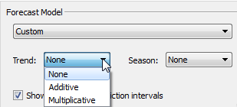

An additive model is one in which the contributions of the model components are summed, whereas a multiplicative model is one in which at least some component contributions are multiplied. Multiplicative models can significantly improve forecast quality for data where the trend or seasonality is affected by the level (magnitude) of the data:

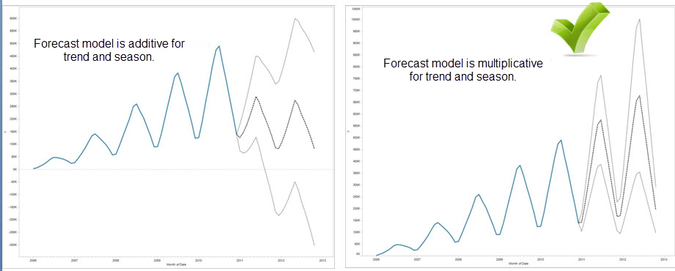

Keep in mind that you do not need to create a custom model to generate a forecast that is multiplicative: the Automatic setting can determine if a multiplicative forecast is appropriate for your data. However, a multiplicative model cannot be computed when the measure to be forecast has one or more values that are less than or equal to zero.

When you are forecasting with a date, there can be only one base date in the view. Part dates are supported, but all parts must refer to the same underlying field. Dates can be on Rows, Columns, or Marks (with the exception of the Tooltip target).

Tableau supports three types of dates, two of which can be used for forecasting:

* Truncated dates reference a particular point in history with specific temporal granularity, such as February 2017. They are usually continuous, with a green background in the view. Truncated dates are valid for forecasting.
* Date parts refer to a particular member of a temporal measure such as February. Each date part is represented by a different, usually discrete field (with a blue background). Forecasting requires at least a Year date part. Specifically, it can use any of the following sets of date parts for forecasting:
* *Year*
* *Year + quarter*
* *Year + month*
* *Year + quarter + month*
* *Year + week*
* *Custom: Month/Year, Month/Day/Year*

Other date parts, such as Quarter or Quarter + month, are not valid for forecasting. See Convert Fields between Discrete and Continuous for more details about different date types.

* Exact dates refer to a particular point in history with maximum temporal granularity such as February 1, 2012 at 14:23:45.0. Exact dates are invalid for forecasting.

**Granularity and Trimming**

When you create a forecast, you select a date dimension that specifies a unit of time at which date values are to be measured. Tableau dates support a range of such time units, including Year, Quarter, Month, and Day. The unit you choose for the date value is known as the *granularity*of the date.

The data in your measure typically does not align precisely with your unit of granularity. You might set your date value to quarters, but your actual data may terminate in the middle of a quarter—for example, at the end of November. This can cause a problem because the value for this fractional quarter is treated by the forecasting model as a full quarter, which will typically have a lower value than a full quarter would. If the forecasting model is allowed to consider this data, the resulting forecast will be inaccurate. The solution is to trim the data, such that the trailing periods that could mislead the forecast are ignored. Use the Ignore Last option in the Forecast Options dialog box to remove—or *trim*—such partial periods. The default is to trim one period.

**Getting More Data**

Tableau requires at least five data points in the time series to estimate a trend, and enough data points for at least two seasons or one season plus five periods to estimate seasonality. For example, at least nine data points are required to estimate a model with a four quarter seasonal cycle (4 + 5), and at least 24 to estimate a model with a twelve month seasonal cycle (2 * 12).

If you turn on forecasting for a view that does not have enough data points to support a good forecast, Tableau can sometimes retrieve enough data points to produce a valid forecast by querying the datasource for a finer level of granularity:

* If your view contains fewer than nine years of data, by default, Tableau will query the data source for quarterly data, estimate a quarterly forecast, and aggregate to a yearly forecast to display in your view. If there are still not enough data points, Tableau will estimate a monthly forecast and return the aggregated yearly forecast to your view.
* If your view contains fewer than nine quarters of data, by default Tableau will estimate a monthly forecast and return the aggregated quarterly forecast results to your view.
* If your view contains fewer than nine weeks of data, by default, Tableau will estimate a daily forecast and return the aggregated weekly forecast results to your view.
* If your view contains fewer than nine days of data, by default, Tableau will estimate an hourly forecast and return the aggregated daily forecast results to your view.
* If your view contains fewer than nine hours of data, by default, Tableau will estimate an minutely forecast and return the aggregated hourly forecast results to your view.
* If your view contains fewer than nine minutes of data, by default, Tableau will estimate an secondly forecast and return the aggregated minutely forecast results to your view.

These adjustments happen behind the scene and require no configuration. Tableau does not change the appearance of your visualization, and does not actually change your date value. However, the summary of the forecast time period in the Forecast Describe and Forecast Options dialog will reflect the actual granularity used.

Tableau can only get more data when the aggregation for the measure you are forecasting is SUM or COUNT. See [Data Aggregation in Tableau](https://help.tableau.com/current/pro/desktop/en-us/calculations_aggregation.htm) for information on available aggregation types and information on how to change the aggregation type.